**MIDDLE EAST TECHNICAL UNIVERSITY**

**DEPARTMENT OF ELECTRICAL & ELECTRONICS ENGINEERING**



**TROY TECH**

**WEEKLY REPORT #3**

**01.03.2019-05.03.2019**

**Section :** 7

**Studio Coordinator:** Mustafa Mert ANKARALI

**Partners :**

Hasan ÖZKARA - 2031888

Kağan ÖZASLAN - 2031854

Caner POTUR - 2031250

Mustafa Ercan OKATAN - 2031193

Mert KAYIŞ – 2030997

**Progresses for Previous Week:**

* We created 3 omnidirectional wheeled robot and tested its basic movements. It could move forward/backward/left/right and turn around itself smoothly. Therefore, we decided to use holonomic control instead of differential drive.

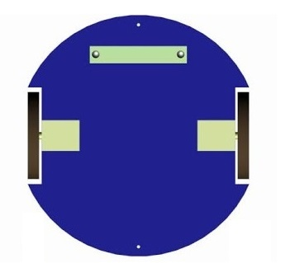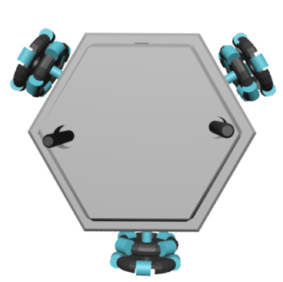

* We created a shooting mechanism using a solenoid, 50V capacitor, 12V to 35V dc-dc step up converter and tested using different voltages. It worked successfully. Therefore, we decided to use solenoid as our shooting mechanism.

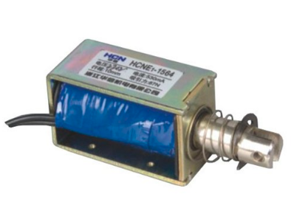

* We discussed about the other subsystems and made definite which methods to use.
* We started to write “Critical Design Review Report”

**Plans for the Next Week:**

* We will order an “Arduino Mega” to combine all subsystems on the robot.

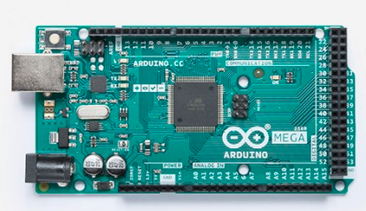

* We will discuss about design and shape (i.e. circle, hexagonal, triangle etc.) of the robot.
* We will start to construct our design.
* We will finish the “Critical Design Review Report”